System Development 2

**Exercise 1: Database Design – Solution 2**

### Exercise 2: Map to relational model - Movies

..



..

**Transform the domain model to a relational model (relational database schema)**

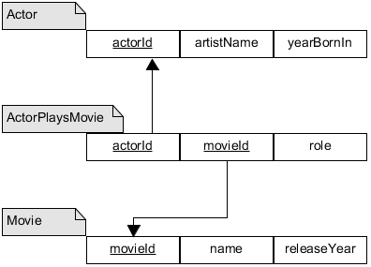

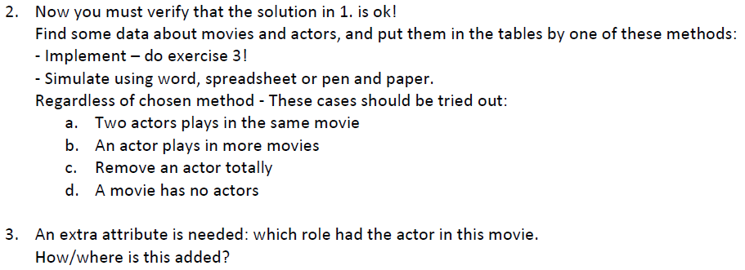

***Create database and tables***

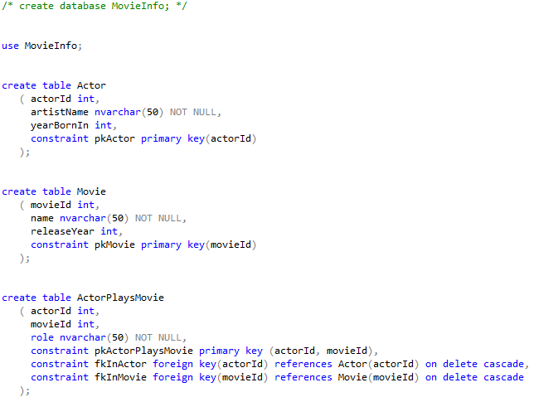

***Insert and delete according to a, b, c***

See sql scripts in sqlForExercise2.zip.